Title: **MicroLogix 1100 Status Screen** Job: 3

Course: Introduction to Automation Unit: Introduction to PLCs CLO: 1, 4

Name ____________________________ Station _______ Date ______________

**Objectives**

1. Student shall understand the Allen-Bradley MicroLogix 1100 PLC status display.
2. Student shall be able to decipher the status of the PLC inputs using the status display.

**Assessment**

Students shall demonstrate a comprehension of the objectives listed above by scoring a minimum of 75% on this shop job. Grading shall be based on the Introduction to PLC rubric.

**Instructions**

1. On the Main Menu screen of the MicroLogix 1100 PLC, use the up and down keys on the LCD keypad to locate the I/O Status Screen.
2. Press the OK button to select I/O Status.

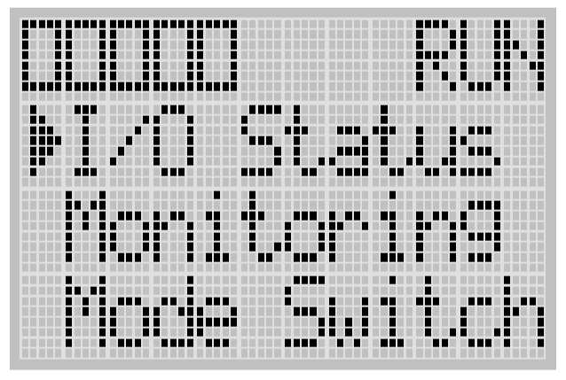

1. The I/O Status screen is displayed. (Input status may differ from picture below)

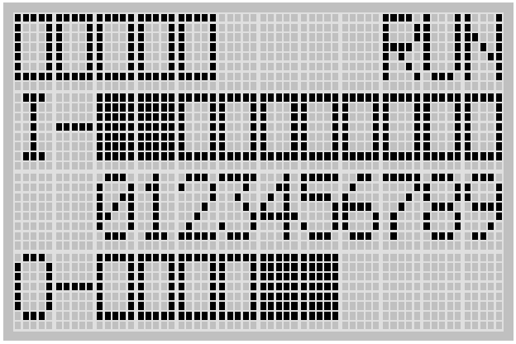

1. Place all the inputs in the following conditions.
   1. ESTOP disengaged (pulled out)
   2. Three-position selector switch in the center, OFF, position
   3. Two-position selector switch in the A position.
   4. None of the pushbuttons depressed.
   5. None of the relays/motor starters “made” (they should be in their shelf state)

|  |  |  |
| --- | --- | --- |
| The input status screen displays a black box for an input that has 24VDC and a hollow box for an input that has 0VDC; |  | Your status screen may appear different. |

This input status screen should show that inputs 0, 5 and 6 have 24VDC.

1. With a multimeter set to measure DC voltage, place the black lead on the DC- of the panel power supply for inputs 0-3. Place the black lead on the DC- of the PLC power supply for inputs 4-8. Use the red lead to test the voltages of each input. Record the results in the table below.

|  |  |  |  |  |  |  |  |  |  |
| --- | --- | --- | --- | --- | --- | --- | --- | --- | --- |
| Panel Power Supply | | | | PLC Power Supply | | | | | |
| I/0 | I/1 | I/2 | I/3 | I/4 | I/5 | I/6 | I/7 | I/8 | I/9 |
|  |  |  |  |  |  |  |  |  |  |

1. While observing the status screen, press the ESTOP. What happened on the status

screen? ___________________________________________________________

1. Place the black lead of your meter on DC- of the panel power supply.
2. With a multimeter, measure the voltage at I/0. Record the voltage. ___________
3. Lift the manual gate on CR1 to force the relay to go to its non-normal state. What

happened on the status screen? ___________

1. With a multimeter, measure the voltage at I/1. Record the voltage. ___________
2. Lift the manual gate on CR2 to force the relay to go to its non-normal state. What

happened on the status screen? ___________

1. With a multimeter, measure the voltage at I/2. Record the voltage. ___________
2. Place the three-position selector switch in the A position. What happened on the status

screen? ___________

1. With a multimeter, measure the voltage at I/3. Record the voltage. ___________
2. Move the black lead of your meter to DC- of the PLC.
3. Place the three-position selector switch in the B position. What happened on the status

screen? ___________

1. With a multimeter, measure the voltage at I/4. Record the voltage. ___________
2. Place the two-position selector switch in the B position. What happened on the status

screen? ___________

1. With a multimeter, measure the voltage at I/5. Record the voltage. ___________
2. Press and hold PB1. What happened on the status screen? ___________
3. With a multimeter, measure the voltage at I/6. Record the voltage. ___________
4. Press and hold PB2. What happened on the status screen? ___________
5. With a multimeter, measure the voltage at I/7. Record the voltage. ___________
6. Press and hold PB3. What happened on the status screen? ___________
7. With a multimeter, measure the voltage at I/8. Record the voltage. ___________